January 1, 2021

Dear Friends and Colleagues,

Happy new year. May this year bring you much happiness and success.

The past long year brought us the pandemic, storms, fires, virtual meetings, political standoffs – we really had a terrible year in 2020. We tried to make the best out of a terrible situation. AMLI and all of you responded in wonderful fashion. As laboratorians we battled unbelievable shortages of reagents, instruments, and plastic ware, we fought an increasing demand for COVID testing, better, faster, and with more accurate results. We had dwindling lab workforces and increasing risks to our safety – yet we gamely continued onwards and gave an excellent account of ourselves. The nation saluted us as heroes as they should have. The prestige and value of laboratories and laboratorians was enhanced. We instituted all sorts of safe measures, led the medical community in defining and following these guidelines. We masked and face shielded ourselves, distanced from each other as we did our work. Courage is not denying fear, it is not allowing fear to hold you hostage. AMLI continued to do its good work. Maggie and Jeff and all the other volunteers kept working for you.

Our 2020 virtual annual meeting was a great success. Our scientific committee put out a great program with a world class faculty. Kudos to them. We are in the midst of planning for a LIVE August annual meeting in Austin Texas. We are optimistic that we will be able to gather in beautiful Austin and celebrate our resilience and hopefully enjoy another great scientific session and enjoy each other’s company. We are hopeful to see all of you there.

Helen Keller once said, “Hope sees the invisible, feels the intangible, and achieves the impossible.” We will keep you updated and post the 2021 meeting announcements on our website.
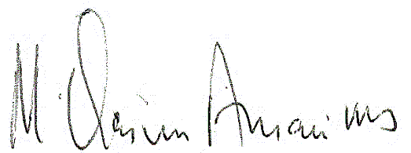
With best wishes,

Qasim Ansari

M. Qasim Ansari, MD
Chief, Pathology and Laboratory Medicine
LS Cleveland VA Medical Center
Professor, Pathology
Case Western Reserve University

