Posted March, 2020
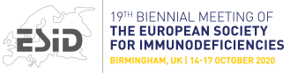Online on October 14-17, 2020
The 19th Biennial Meeting of The European Society of immunodeficiencies (ESID)
will further the knowledge in the field of Primary Immunodeficiency (PID)
by promoting the latest research, offer high-quality educational programs and foster indispensable cooperation
among all those involved in the diagnosis, treatment and management of these diseases.
FOR MORE INFORMATION:
ESID 2020

